I implemented the changes stated in the thesis,

And modified the missing changes such as

Inorder for the EDF scheduler to work correctly, you still need to implement some changes that are not mentioned in the thesis:

"1. In the ""prvIdleTask"" function:

Modify the idle task to keep it always the farest deadline"

"2. In the ""xTaskIncrementTick"" function:

In every tick increment, calculate the new task deadline and insert it in the correct position in the EDF ready list"

"3. In the ""xTaskIncrementTick"" function:

Make sure that as soon as a new task is available in the EDF ready list, a context switching should take place. Modify preemption way as any task with sooner deadline must preempt task with larger deadline instead of priority"

Here is a screenshot of all tasks running

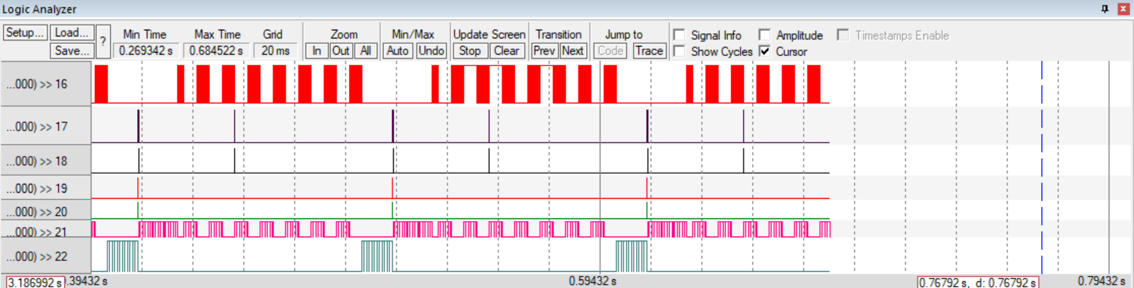

All tasks meet their deadline ,from the pattern we see the **hyperperiod=100.**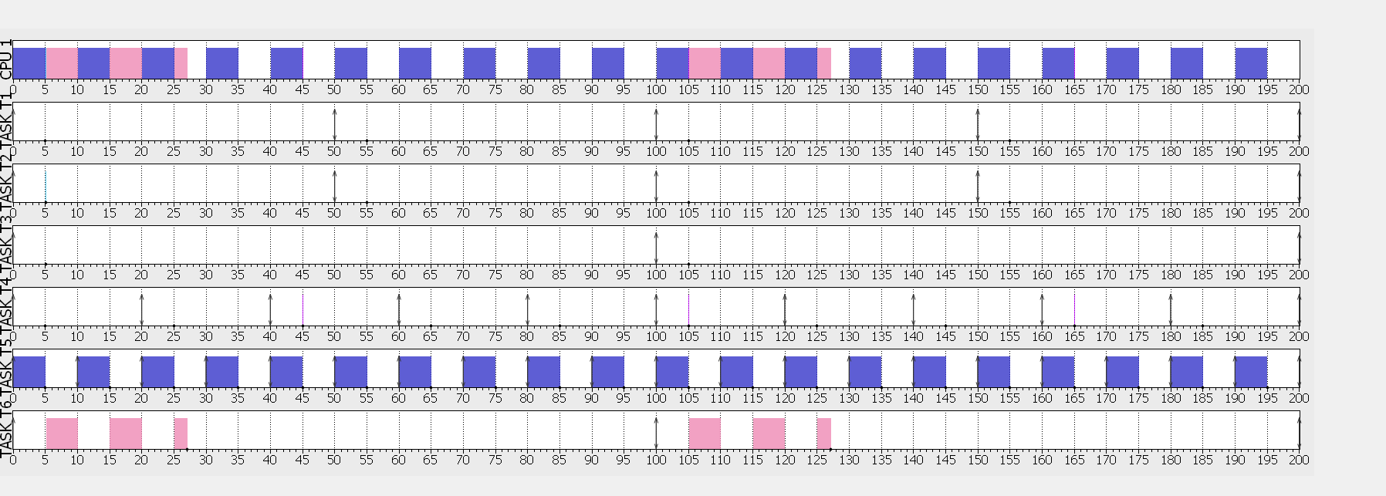

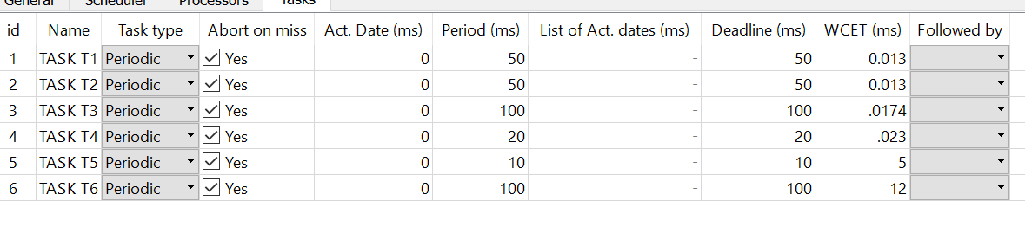

**CPU load** = execution time /period

=(.013/50)*2 +(0.0174/100)+(0.023/20)+(5/10)+(12/100) = **0.626**

**URM**

U <= n*(21/n – 1)

6* (21/6 -1)= 0.73 > 0.626 system schedulable

**Time demand analysis**

W(10) = 5 + 0 = 5 < 10 feasible

W(20) = 0.023 + 5*2 = 10.023 < 20 feasible

W(50) = 0.013 + 5*5 +0.023*3+0.013 = 25.095 < 50 feasible

W(100) = 12 + 5*10+0.023*5+2*(0.013*2)+0.0174 = 62.18 < 100 feasible

As well as all tasks were feasible then system is schedulable